Feature Image: Start your makeup artistry journey today—enroll now!

Title: The Best Beauty School Services for Aspiring Makeup Artists
Focus Keyword:
beauty school services
Secondary Keyword:
cosmetology school houston
cosmetology courses
Houston Cosmetology Program
Cosmetology Program
Houston Beauty School

Internal Links:
cosmetology school houston: https://imageacademy.org/
Houston Cosmetology Program: https://imageacademy.org/courses/

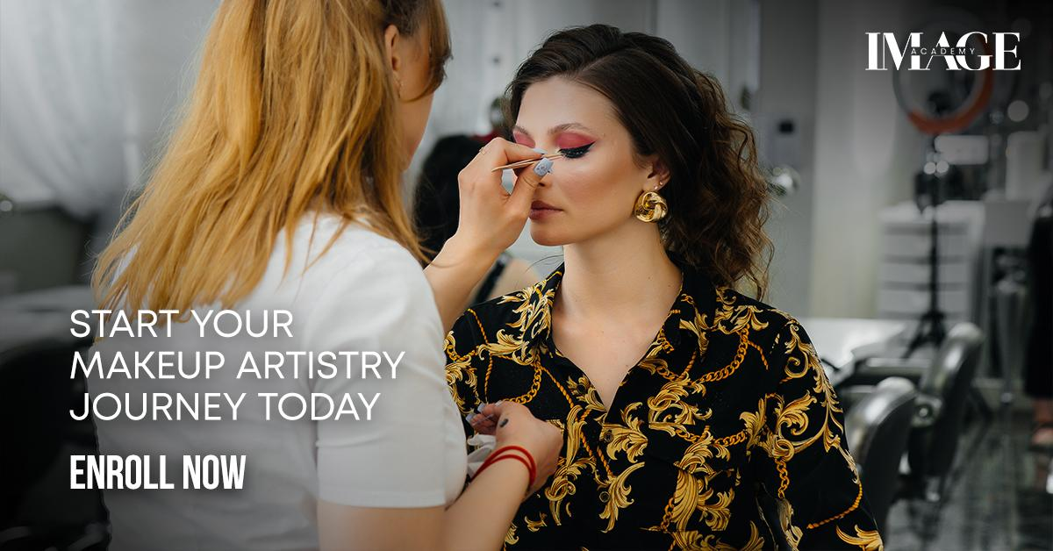

The Best Beauty School Services for Aspiring Makeup Artists H1
Choosing a beauty school feels exciting, maybe even a little overwhelming. You see the potential, the creativity, the chance to build a career doing something you love. As an aspiring makeup artist, you know mastering the brush is key.
But here’s the insider knowledge we’ve gained from over a decade of training Houston’s top talent at Image Academy, which is that your success hinges just as much on the entirety of your beauty school education. Relying solely on makeup classes is like building a house on sand. You need a rock-solid, comprehensive foundation in all core beauty school services. This isn’t just our opinion. It’s what working makeup artists tell us daily that shapes their careers.

Why Every Service Matters to a Makeup Artist (Beyond the Obvious) H2
You might wonder, "Do I really need to learn back waxing or a basic facial if I want to do bridal glam?" The answer, forged through watching countless graduates thrive, is a resounding yes. Here’s why a truly rounded cosmetology program is non-negotiable.

Understand Skin at a Deeper Level H3
Makeup sits on skin. Period. Studying facials, acne treatments, dermaplaning, and microdermabrasion gives you an intimate, hands-on understanding of skin types, conditions, textures, and sensitivities you simply cannot get from makeup theory alone.
Here, you will learn how products interact with the skin barrier. You see how treatments like our "Woo Me Facial" (dermaplaning) create that ultra-smooth canvas clients crave. This knowledge directly translates to better product selection, application techniques, and managing client expectations. Imagine confidently advising a bride with rosacea because you understand the underlying condition.

Master Hair Fundamentals is Power H3
A stunning makeup look can fall flat with poorly styled hair. Learning blowouts, precision haircuts, and color theory in your cosmetology courses teaches you about balance, proportion, and how hair frames the face. You understand how hair texture and color influence makeup choices. You learn to collaborate seamlessly with hairstylists or even offer basic styling tips yourself, which makes you a more versatile artist on set or at the salon chair.

Brow Expertise is Your Secret Weapon H3
Perfectly groomed brows transform a face. Eyebrow waxing, tinting, and lamination services taught in our quality cosmetology school Houston are the essential skills for the advancement of your career. You learn brow mapping, shaping for different face shapes, and color correction. This expertise allows you to offer brow grooming as an add-on service or ensure your makeup application complements the brow’s natural architecture flawlessly.

Lash Skills Upgrade Your Offering H3
Lash lifts and tints are incredibly popular. Learning these services alongside makeup means you can offer complete eye enhancement packages. Understanding lash health, curl patterns, and safe tinting procedures makes you a more valuable artist. You avoid the pitfalls of applying mascara over irritated lashes or knowing when to recommend a lash service instead of heavy makeup.

Build Client Trust Through Versatility H3
Clients seek professionals who understand their whole beauty journey. When you can discuss skin care concerns knowledgeably after a facial lesson, or suggest a brow tint to enhance their look, you build immense trust and credibility. This holistic approach sets you apart and fosters client loyalty. We see it constantly with our graduates.

Expand Your Service Menu & Income H3
The beauty industry rewards versatility. Having waxing, basic facials, lash services, or hair skills on your license allows you to diversify your income streams. You can fill appointment gaps with brow waxes or lash lifts. This flexibility is crucial, especially when starting your career.

How does the Choice of Your Beauty School Services Truly Impact Your Makeup Career? H2
Not all cosmetology programs are created equal. Your future as a makeup artist depends heavily on the specific Houston Beauty School services offered and how they are taught. Here’s what to scrutinize based on what we know works:

Sanitation and Safety Protocol Integration H3
This is non-negotiable and must be woven into every service module, not just a standalone lecture. At Image Academy, sanitation is drilled daily from day one in every practical session, such as proper disinfectant soak times for waxing pots, single-use applicators for tints, and sterilization of makeup brushes and tools. Why? Because, as a makeup artist, you work intimately on faces. Cross-contamination is a real risk. Schools that gloss over this put you and your future clients at risk. Ask specifically about their sanitation protocols for makeup stations and shared kits.

Skin Science Focus H3
Look beyond basic skin type classification. Image Academy's best Houston cosmetology programs delve into common skin conditions (acne, rosacea, eczema, hyperpigmentation), skin anatomy, product ingredients, and how treatments affect the skin. Our "Show Me Love Facial" (acne treatment) module, for instance, teaches you how certain makeup formulations can aggravate or help acne-prone skin. This knowledge is gold for a makeup artist.

Comprehensive Brow Curriculum H3
Ensure the program covers more than just basic brow waxing. Look for detailed instructions on brow shaping techniques (tweezing, threading basics alongside waxing), precision arch mapping, tinting for different hair colors and skin tones, and the increasingly popular eyebrow lamination. Understanding the growth cycle and how to avoid over-waxing is critical.

Lash Service Depth H3
Lash lifts and tints require precision and safety knowledge. The program should thoroughly cover eye anatomy, patch testing protocols, chemical processing times, proper isolation techniques to avoid skin contact, and recognizing contraindications. Ask if they teach both pad-based and shield-based lift methods. Our lash tech instructors emphasize that mastering the consult is as important as the technique.

Meaningful Hair Modules H3
As a makeup artist, you don’t need to be a master colorist, but you do need solid skills in blow-drying techniques for various textures, basic thermal styling, understanding haircuts and how they affect styling, and fundamental color theory (how undertones work). Look for hands-on practice sessions focused on styling that complements makeup looks.

Facial Treatments with Practical Relevance H3
Facials for makeup artists aren't about becoming an esthetician. Focus on programs that teach practical skills like thorough skin analysis, proper cleansing and prep techniques, extractions (if within scope), mask application, and basic massage. Understanding treatments like our "Surprise Me Facial" (microdermabrasion) teaches you about skin resurfacing and its impact on makeup application, timing, and product choice.

How Image Academy Makes a Difference for Makeup Artists?H2
We built our Houston Cosmetology Program knowing aspiring makeup artists need more than a checklist of services. They need context, integration, and real-world application. Here is how we do that:

Integrated Learning H3
We don’t teach waxing in isolation. We discuss how brow shape fundamentally alters facial balance and impacts makeup application. In hair modules, we practice styles that showcase makeup looks. Facial training directly informs our makeup product selection lessons. This connected approach mirrors how you’ll work with clients.

Client Consultation Focus H3
Every service, including makeup, starts with a deep consultation. We train you to ask the right questions, perform skin assessments, manage expectations, identify contraindications, and recommend appropriate services. This communication skill is paramount to client retention and safety. You learn to consult not just for makeup, but also to understand a client’s overall routine.

Hands On Hours That Matter H3
State minimums are just a starting point. We prioritize extensive, supervised practical experience. You perform services on real clients at the Image Academy student clinic early and often. This builds confidence and muscle memory for you under our guided supervision. You don’t just learn how to do a lash lift. You learn how to do it well, efficiently, and safely through repetition.

Industry Standard Products & Tools H3
Training on cheap, outdated products sets you up for failure. We use professional-grade products and tools across all services. From the waxes and tint brands used in top salons to the high-quality makeup and brushes, you’ll encounter everything in our beauty academy and learn perfection. You learn how real products perform.

Makeup Artist Specific Business Modules H3
Your education shouldn’t stop at technique. We incorporate essential business skills bespoke for you, such as building your portfolio, pricing your services, retailing skincare relevant to makeup, sanitation for freelance work, and client management strategies. We know what it takes to run a successful makeup business in Houston.

Instructors Who Are Working Professionals H3
Our faculty aren’t just teachers. They are active makeup artists, estheticians, and stylists working in Houston salons, on photo shoots, and with brides. They bring current trends, real client challenges, and industry connections directly into the classroom. You learn the realities of the field.

Final Thoughts H3
Choosing the best beauty school services as an aspiring makeup artist is about investing in your complete professional toolkit. It’s about understanding the canvas you work on, inside and out. It’s about offering value beyond the foundation and mascara.
At Image Academy, we’ve designed our entire Houston Cosmetology Program with your specific goals in mind. We integrate essential services like skin treatments, brow mastery, lash techniques, and hair fundamentals not as separate boxes to tick, but as interconnected skills. Such skills will empower you to be a truly exceptional, knowledgeable, and versatile makeup artist.
Don’t settle for a program that just teaches makeup application. Seek a comprehensive cosmetology school in Houston that builds the deep, practical foundation you need for long-term success. Visit our website or contact us today to learn more about our program designed for real-world makeup artistry success. Your journey to mastering beauty starts with the right education.

GMB Description:
Are you an aspiring makeup artist? Your foundation matters more than you think. At Image Academy, Houston’s trusted beauty school for over a decade, we train artists who truly understand the entire canvas. We know because our graduates work with Houston’s top salons, brides, and photographers. A great makeup artist doesn’t just master color. They deeply understand skin, brows, lashes, and how hair frames the face. That’s why our comprehensive cosmetology program integrates essential beauty school services into your core training. You’ll gain hands-on experience in skin analysis through facials like our acne-focused Show Me Love treatment and dermaplaning Woo Me facial. You’ll master brow shaping, waxing, tinting, and modern lamination techniques critical for facial balance. Learn lash lifts using both pad and shield methods, plus safe tinting protocols. Develop hair skills like blowouts and basic cutting that complement your makeup artistry. We go beyond state board requirements. Our instructors are working Houston beauty pros who teach you real-world sanitation drills daily, client consultation skills for every service, and how to connect skin health to makeup choices. Tour our Houston facility. See professional product kits, meet artist instructors, and discover how our beauty school services create truly exceptional, employable makeup artists. Let us help you build a complete skill set for lasting success. Your artistry deserves the right foundation. Start your journey with Image Academy today.

